Thaana: A Challenge to Information Technology
Dr. Hassan Hameed
Maldives College of Higher Education
The aim of this paper is to invite the readers to reflect about the following thoughts:
1 – The era Dhivehi was written in Thaana. Why this was started and how the letters were formed.
2 – The placement of letters in Thaana typewriter keyboard and how different keyboards were formed
3 – The challenge in writing Thaana in Microsoft keyboard and how to solve the problems.
4 – A few things that can be done to develop Thaana.
5 – The internet and Thaana web pages.
1 – The creation of Thaana
Thaana is the most scientific system used to write in South Asia according to De Silva who was an expert on written form of languages. Books are written often how letters were created in different languages. In 1996 a book called “The World Writing System” was published in which its two authors agreed with De Silva that Thaana is in fact the most scientific alphabet in the South Asia.
What is the beginning of this brilliant language? Most of us know how Thaana was formed. The formation of Thaana was taught to us in school. However it seems that we sometimes get confused how the Thaana letters were formed. The reason why I mentioned this is that, in a recent publication in a local newspaper, it was written that Thaana is somehow affiliated to Africa. This piece in the newspaper was used as a reference for a book written to students later. It seems to me in the future, the beginning of Thaana could also be credited to the some other country. When an empire gets too powerful it brings all of the inventions in the world to them and they are credited with the inventions. On the losing end are often nations with few inhabitants.
Therefore in this paper I will put forward to you what I think is the beginning of Thaana letters and why I believe so. You would have to decide on your own. I wait for the day when people who say the origin of Thaana letters are taken from another set of letters, submit their evidence.
As a start for this paper let us reflect on a piece a Maldivian author has written about the subject. The author is Hussain Salaahuddeen, who we all deeply respect. The book is called “Masterpiece Language for Dhivehi Language Students” published in 1926. In it Salaahuddeen states:
“There are 24 letters in Dhivehi Thaana. The first nine letters are based on Arab rules. The second nine letters are based on Dhivehi rules. The remaining six letters are Dhivehi letters formed on our own rules”. (Page, 16)
In the book Salaahudden writes that the letters formed on our own were based on the first 18 letters of Thaana. For example ޗ was formed by modifying ތ. This was the same for all the letters we formed with the exception of ޓ. ޓ was formed by rotating a letter used in the old Dhives letters. Salaahuddeen’s book offers us even more insight into Thaana letters.
For people who want to look it up, I have contributed a copy of the book to the library in Teachers Education Center.
Do you want more evidence of how the first nine letters were formed? However the Arabic and Thaana letters are so similar I believe more evidence is not needed. When the letters were first formed it was even more similar. The following is the page 438 of Derringer’s 1968 book, “The Alphabet” about how numerical numbers have changed over the decades. He highlights how Arab letters were written in this region when Thaana was first formed. Even now in Persian language these kinds of letters are used. The letters ނ،ށ،ހ are very similar to Arab numerical numbers. The similarities are more visible when you compare the two set of letters. For this purpose the following is a page of Raadhavalhi (a publication in which the history of Kings are written).
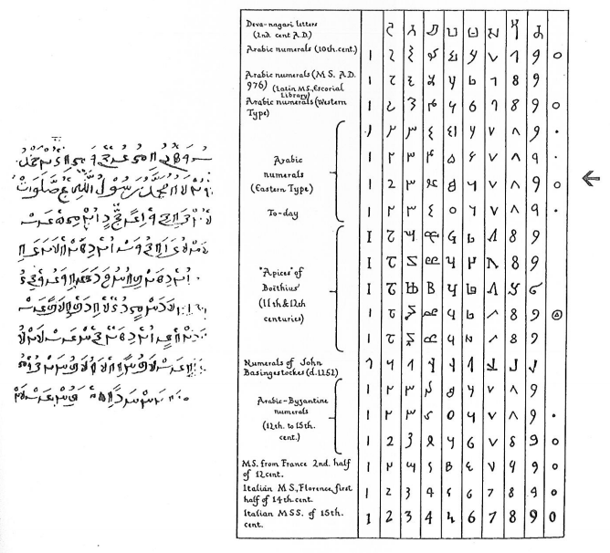
The next nine letters, from މ to ޑ, are actually numerical numbers we used before from 1 to 9. These numeric numbers were also used at the time in Ceylon and India too. Now, these letters are sometimes even called “Dheyvaanagaarii” numeric letters. The proof is Loamaafaanu. The pages of the Loamaafaanu are numbered in this numeric letters. Thaana letters and the numeric letters used in those days are very similar. Another proof of is the Thaana letters ދ،ފ،މ that were used as numeric letters in a Raadhavalhi published by the History and Heritage Center in August 5, 1979. In the book the letter މ is used for the numeric letter 1 and the letter ފ for 2. The numeric Dheyvaanagaarii letters Maldivians used at the time are still being used in some areas of the Hindustanis. However now, the letters are written very differently. But there are similarities of the form of the letters.
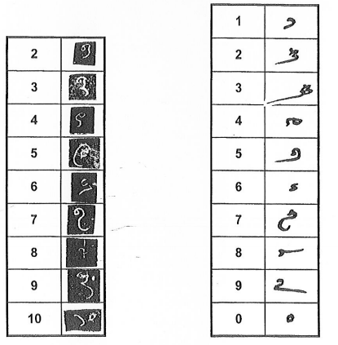
Right side: Numbers used in the book “Raadhavalhi” by Parliament, released in 5 august 1979. showing the numbers used back then.
Left side: This shows the numeric used in 1190. Taken from “Loamaafanu” from “Hahdhunmathi, Dhabidhoo”.
Next I will look at the origin of Thaana letters from papers around the world. In this paper I will reflect on books that have never been heard in Maldives before. From the libraries I searched the oldest book I found was Samuel Johnston’s book published in 1848.
The most authentic book I found was the two volumes of was David Derringer’s “The Alphabet: A Key to History of Mankind” published in 1968. For the purpose of this book I searched massive with thousands of book but none other than Derringer had detailed the beginning of Thaana. Derringer has detailed his work about Thaana in page 307 of his book. The following is a small translation of the piece.
“In the 1700 and the 1800 Dhives letter started to make way for Thaana letters. However in the southern atolls Dhives letters were used in the 1900 as well.
‘Gabulhi Thaana’ or Thaana is Dhivehi letters with a particular interest. These letters were formed from Arabic numerical letters, Dhivehi numerical letters and Arabic-Persian letters. Mainly there are 26 letters in Dhivehi alphabet. From this the last eight letters are part of Arabic-Persian. These letters are used if needed to pronounce Arabic and Persian sounds. The first nine letters of Thaana is the Arabic numerical letters from 1 to 9. The second nine letters are Dhivehi numerical letters from 1 to 9. Dhivehi numerical letters have similarities to Sinhala and India’s numerical letters. The letters are written from right to left as Aramaic letters. Moreover in opposite to old Dhives, Sinhalese and Indian letters, a Thaana letter without a diacritic does not make a sound. The letters make sounds from diacritics that are written above and below the letters. From these characters we can conclude that the origins of these letters are from the Arabs.
There are two or three types of Thaana. These include secret alphabets in which sounds of two letters that are next to each other are changed. “Hashathaana” and “Dhefuhthaana” are significant examples. The sounds of first and the last 13 letters of “Dhefuhthaana” alphabet are changed.”
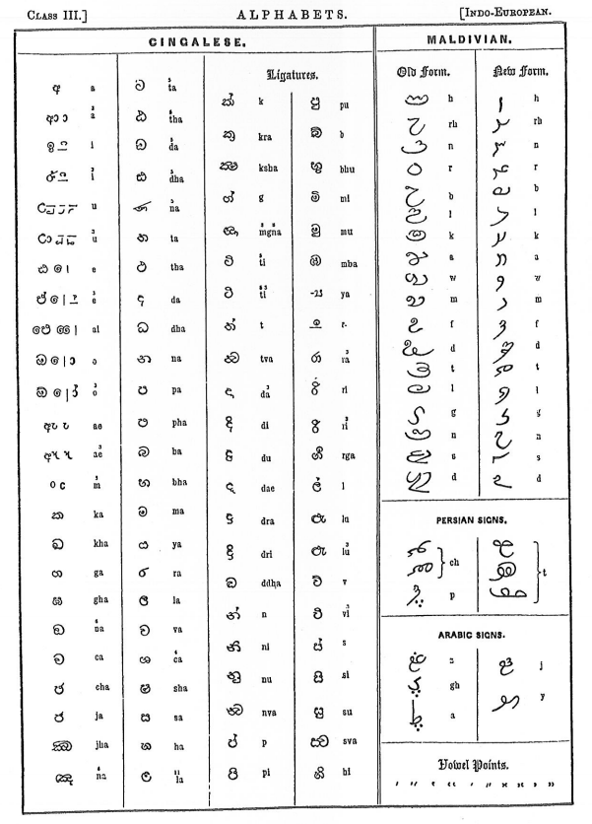
A part of Page 50 from Samuel Johnston’s book
I worked hard to find the first document in which Thaana was used however I wasn’t able to find much progress. In “A New Light to Maldivian History” published by the Center for History and Linguistic, it is written that the oldest document written in Thaana found to date, dates back to 1599. This document was found in a door of a mosque in Shaviyani atoll Kanditheemu Island. In Male’ the oldest and the easiest to find Thaana document can be found carved at a coral stone in “Kalhuvakaru” mosque. This document dates back to 1789.
The changes to the form of the letters
Over the years the form of Thaana letters has changed. In the oldest documents Thaana letters were straight, similar to Arabic and Dhives letters. But later letters became longer and was rotated slightly. Thaana documents dating back 50 years from now were written like this. When Thaana is written in this format it is difficult to differentiate between the letters because the letters are long. In a book written by Geiger in 1919, H.C.P Bell writes:
“There were nothing made of material to print Thaana letters that had a set standard. Because of this there was a particular “fastness” when Thaana was handwritten. As a result the differences between the letters slowly vanished, unnoticed.
Stating the truth, we all have to agree that the changes made to Thaana in the past two decades, in fact did not have a distinct difference between the letters. It also did not beautify the letters more than before. Opposite to that the chirographic quality of the letters went lower.” (Page 165)
The letters of Thaana were made smaller, like how they are now, 50 years ago. Before that, the letters were longer but easy to read. This change was made very slowly. The letters we use now were made 50 years ago.
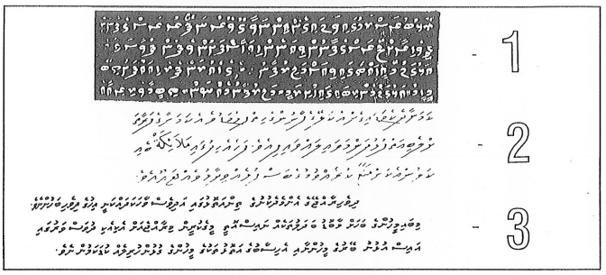
Changes in how thaana was written.

Efforts made to improve Thaana
There has great efforts made in the past to develop Thaana alphabet. However our generation has but received a small amount of this work. In this manner the most significant invention was Himithee Abdulla “Thuhthu Saahib” Ismail’s “Vadaankashi Thaana”.
An author, Abduh Raheem Abduh Majeed, informed me of how Ismail’s work started. The people of Athiree, where Ismail belonged to, were people who owned fishing vessels. One day a person from one of the atolls brought a tool used to empty water from the vessel to Athireege. In the tool “Athireege” was written in Thaana carved from a carpentry tool. Realizing the importance of this Ismail made all of the Thaana letters diacritics in that format. To spread the letters in Male’, he had them printed in India and distributed them around Male’. Ismail told Abduh Raheem the author that he planned to place the diacritic next to the letters, in his new version of Thaana. He even gave a copy of the letters to Abduh Raheem. Unfortunately Ismail died a week later.
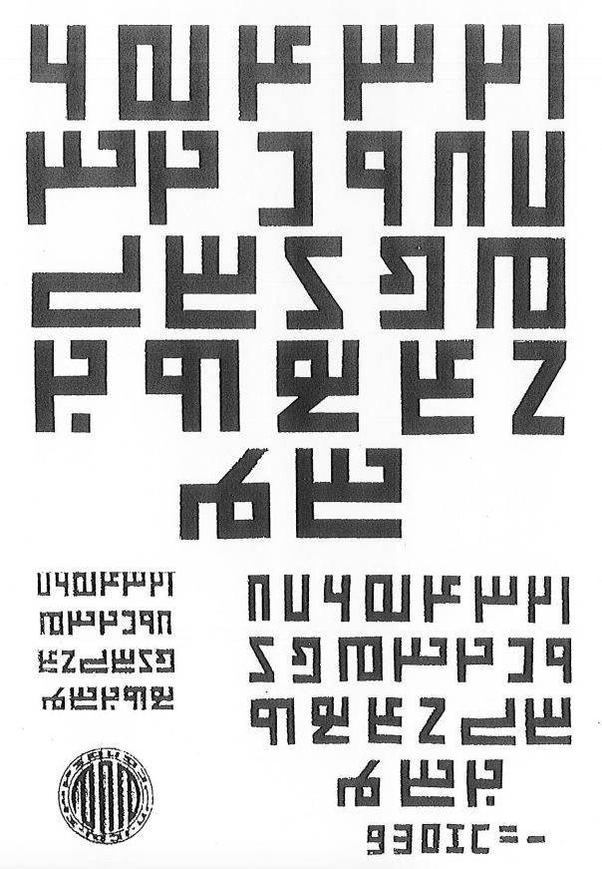
A copy of “vadaankashi Akuru” printed from India.
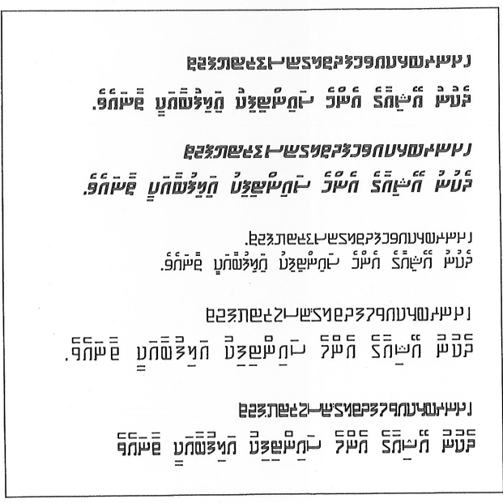
A set of thaana characters designed by Hassan Hameed. It was inspired by the oldest akuru forms. Those who understand Thaana could read these without any difficulties.

I think one reason why Ismail’s set of letters failed to gain popularity was because it was so different from the Thaana alphabet. The letter ފ is a good example of this. In my point of view, even if letters are changed or altered it should not appear foreign to a person who knows Thaana. Furthermore Ismail decision to place diacritics next to the letters rather than above and below, was a totally new format. Most changes are only easy to bring slowly.
Therefore, as Ismail’s invention is in the national archive and because it helps develop Thaana, I have made approximately six fonts similar to it. In making the fonts I looked at Vadaankashi Thaana and the oldest Thaana as originals.
Abdul Azeez Yousuf, who worked on developing Thaana letters for typewriters, recommended replacing the letter ސ by inventing another letter in its place. In this manner the bottom of letters ސ and ށ were recommended to be changed as the letter ޏ. But as the letter ސ is wider than the rest of the letters, when the diacritic is placed to the length of it, it just wasn’t suitable. Therefore it was proposed to shorten the letter. However it did not become popular.
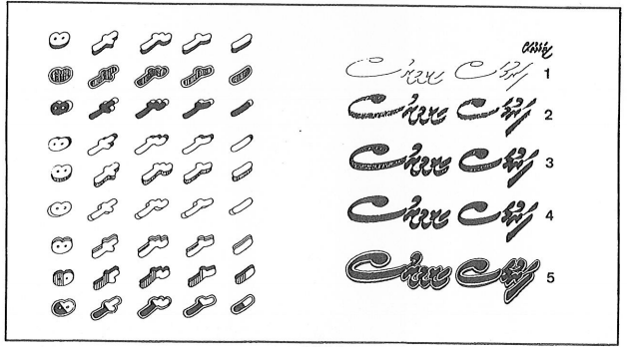
Saikura Ibrahim Naeem and and Copy Mohamed Rasheed’s thaana in ads.

Ibrahim “Saikuraa” Naeem, in his 1998 book, “Raivilla” stated that he fashioned some of the Thaana letters to fit a much faster handwriting. These letters are used unofficially in the Maldives. In illustration seven you could see some of Naeem’s writings with the letters he fashioned. According to Naeem, these letters were first used in the 1960’s.
Moreover Mohamed “Copy” Rasheed created 100 styles of Thaana in his 1995 book “Thaana, Big Letters”. Most of the styles in his book would be of one family if looked critically from a typography point of view because the main characters of the letters were not changed.
Abduh Raheem Abduh Majeed made Thaana letters in hexagons and proposed it to the government. In my view all of the work mentioned above has help make Thaana rich.

Thaana Keyboard
Thaana keyboard was first invented when Thaana typewriters were introduced. Abdul Azeez Yousuf, who was personally involved in the making of the Thaana typewriters, told me the first Thaana typewriter was invented by a man called Naseed from Addu atoll. Naseem used to work as a mechanical engineer in India. He made two prototypes of Thaana typewriters in the early 1970’s and gifted it to the then President Ibrahim Nasir. But the work was transferred to the next president, Maumoon Abdul Gayoom and the then Education Minister who started work on this. Thaana typewriters were introduced to Maldives in February 22, 1984. Abdul Azeez Yousuf worked on developing and placing Thaana letters in these typewriters.
In developing the Thaana keyboard Abdul Azeez Yousuf mainly looked at the frequency of how the letters were used in government letters and official documents. To calculate the frequency of the letters used, he also looked into how often the same letters were used and also the frequency of which diacritics were used. He placed the most frequently used letters at the home keys or next to the home keys. The keyboards of Thaana typewriters were very carefully placed.
After Thaana typewriters were introduced, soon computers were also introduced in the Maldives and because of this a Thaana compatible program called “Multi Lingual Scholar” was also introduced. Because this programed allowed users to place keyboards however they wanted, workers compared the sounds English and Thaana letters made and placed Thaana letters similarly to where the same sound making English letters were placed. This kind of placing is called phonetic keyboard. Phonetic keyboard can be used by a person who does know Thaana keyboard well. For example if you press the letter J in Thaana keyboard it will come out as ޖ. These two letters make the same sound.
The program Multi Lingual Scholar was bought by the President’s Office and the letters were developed by some of the office’s staff. Previously this program was sold by a company called “Sega”. In this paper I have named this keyboard as “Sega Keyboard”. Sega Keyboard is not the same as the phonetic keyboard. In phonetic keyboard, for example if you press the letter A, in Thaana the letter އ would come out. However in Sega keyboard if you press A, a diacritic would come out.
At the time I worked on developing a Thaana writing program using BBC microcomputer. I finished the project in 1988. When I worked on this I didn’t thee the Multi Lingual Scholar. I placed the keys in similar places as the phonetic keyboard. In places where I could not place the letters in similar places as the phonetic keyboard, I placed the letters looking at the form. For example you can write ފ by pressing Shift F simultaneously. After that in all the fonts I introduced to Maldives, I placed the keyboard as I placed the keyboard in my first Thaana writing program. The fonts introduced to this keyboard all starts with an A. Abdulla Waheed and Hassan Sujau who worked at the President’s Office then, worked with me on the project. When Leftinent Mohamed Nasheed who worked in the military and I bought a program called Accent Express and introduced it to Maldives, phonetic keyboard rose in the market.
However the phonetic keyboard is not a good keyboard per say. In phonetic keyboard, the writer is slowed down because the letters used most frequently is placed in the same area forcing the writer to type most letters with one hand. So it is important to invent a keyboard similar to typewriters in Maldives. But in my view the typewriter keyboard is also not perfect. Adam Halid, from Silver house in Galolhu ward and me experimented on the typewriter keyboard and we noticed some of the most frequently used letters were not placed in the most comfortable places. We counted the letters of condense education program’s Dhivehi book using computer. This book contained more than 100 pages and around 100,000 diacritics. Our result is in table one. In counting we also looked at how frequent different diacritics were placed in a letter. That result can be seen in table two.
The second reason why Thaana typewriter keyboard should be further developed is because some letters are repeated in two different keys of the keyboard. Keyboards now don’t have letters repeated in different keys. The typewriter keyboard is developed with a very small amount of keys. As the computers keyboard has more keys compared to typewriter keyboard, it is important to find a use to these keys in Thaana. Moreover the Dollar and Pound sign keys in the typewriter are not useful in my view. That’s because with a computer keyboard these signs can be used in multiple different ways. Also, in the future we might have to use different kinds of brackets and obelisk. For example in “Windows” the reverse obelisk sign (\) is used to find a file.
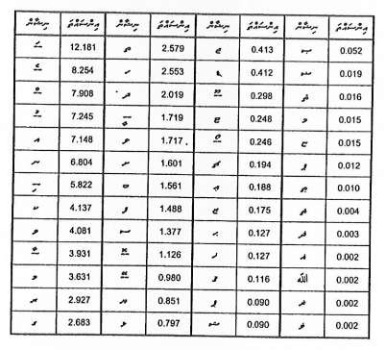
Table 1: The percentage of akuru used in thaana. To calculate this more than 100,000 “fili and akuru” were counted
In most countries, in general, only one keyboard is used. But in some countries a phonetic keyboard and a keyboard faster to write is sometimes used. As the English language has become a nationally adopted language, a phonetic keyboard is important to a country. And to develop Thaana a modern keyboard is needed, which has placed frequently used letters in its best places. So I have made one. I made this keyboard after researching the statistics of the frequency of which the letters are used and the policy of Thaana. The main keyboard’s where Thaana is used is illustrated below. It is important to have an official and modern keyboard in Maldives which everyone uses. As most documents are typed using computer nowadays, it is important to develop a modern and official keyboard as soon as possible.
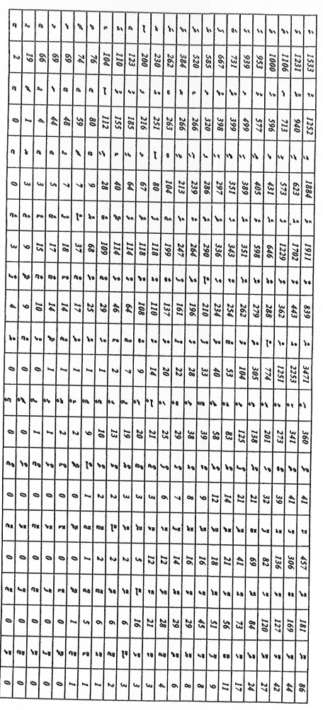
Table 2: Most commonly used “fili” and “akuru” combination in the samples which were not used.
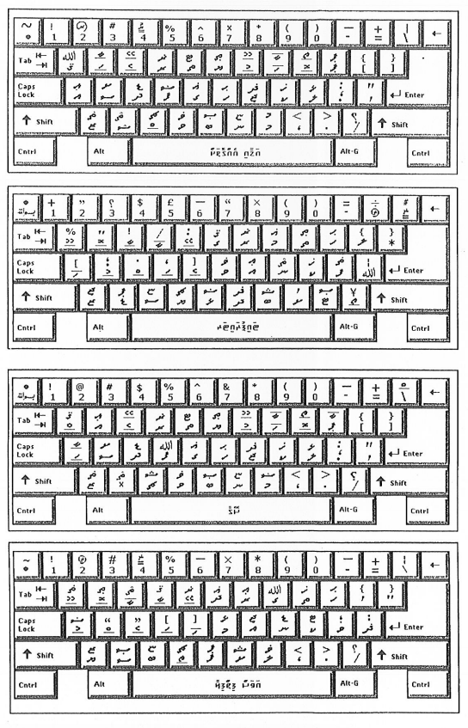
Keyboards generally used for writing Thaana
3. Some inconveniences in writing Thaana on Windows and their solutions
Around six programs are used in Maldives for writing Thaana on computer. These programs are operated with another large program that “speaks” with the electronic equipment of the computer. This program is called the operating system. The most popular operating system in the Maldives is called Windows. All programs used for writing Thaana “speaks” to the operating system. Thaana program will not function without an operating system. The program used for writing Thaana will not be able to function properly if the operating system contains any errors.
In this part of the paper, I intend to look into the challenges caused in writing Thaana on Windows operating system. Some of these difficulties are common to all types of operating systems.
- Misalignment of slanted lines

When Thaana is written on computer, it is usually seen to the human eye on paper or on the screen. In both cases, the slanted lines are more unpleasant to the eye compared to the parallel lines. This is because the printer or the screen uses round dots to make the writings. These dots can only work in the center of cube-like boxes as those similar to mathematics books. The illustration below (illustration 9) will further clarify this impression.

As Thaana is writing in which all letters have slanted lines, it is difficult to bring out the actual depiction of the letters by using dots in boxes that are not slanted. This challenge can be overcome if the dots used for writing are very tiny. As these dots are quite wide in screens (72 dots in 1 inch), the screen does not show Thaana writings in its true form and quality. In contrast, the letters are in better quality on paper because printers can put around 1,200 dots in 1 inch. English letters have high quality on screen as these letters are made up of many parallel lines. As the illustration 9 below shows, parallel lines can easily been drawn on cube-like boxes.
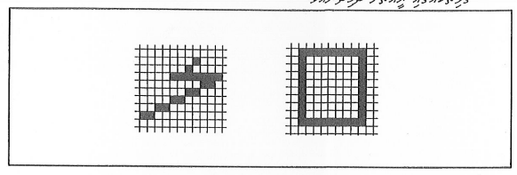
How we see letters from the screen/printed.

When we look into the main letters used for writing languages around the world, almost all languages use major parallel lines to write. One reason is that these lines are more clear and visible. According to the earlier mentioned book of Derringer, the author had not come upon any other language except Thaana in which all letters and diacritics are slanted. Those who contemplate about the future of Thaana must find ways to make the lines more level. More parallel lines, like those used in English, might have to be adopted for Thaana. However, it is more important that we find a way to write Thaana in straight lines.
- The ‘X height’ is an expressive term in typography. In short, it is a height used to describe letters by referring to the shapes. In Latin words, it is the height of a simple x. The x height in Thaana is the slanted height for a letter such as ގ. This height indicates the shape to represent different letters. For example, when writing ސ in the height of ގ, we know that the shape represents the letter ސ. However, the x height is not applicable to the letter ޗ. In contrast to Latin letters, Thaana x height is in reality altered for different letters. With relevance to the width of the writing line, the bigger the x height, the easier it is to read the writing.

When Thaana and English are written on a line with equal width, it is clear that the x height of Thaana letters become smaller. As a result, when English letters are minimized so that it is barely able for the viewer to read, Thaana letters cannot be read at all. In other words, to write Thaana letters so that it can be easily read, a line wider than that used for writing English is essential. This issue caused by the x height is not only faced by Thaana letters, but also in Arabic letters. One solution for the Arabic letters in Windows 2000 is to extremely increase the x height of letters. This can be clarified by referring to the manual of the Windows 2000. In the manual, Arabic letters ‘Alif’ and ‘Laamu’ is shortened while the curves in letters such as ‘Soadhu’ are enlarged. Although the letters are not pleasant to the eye, there are no difficulties in reading them. A forthcoming part of this paper will focus on how this can be adopted for Thaana.
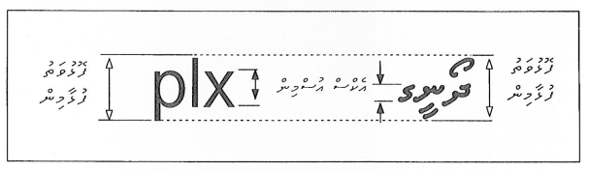
Comparison of Dhivehi and English typed in same x height. Thaana Akuru X height is drastically smaller compare to English.

- Differences in baseline

Latin letters are written on top of the line. Arabic letters are also written on top of the line. However, Thaana is written below the line. This causes some problems in writing Thaana. In typography, the lines used for writing is called the baseline.

Some Arabic and English words are commonly used in Dhivehi articles. When an English word is written on a Thaana baseline, the word is oddly placed on top of the baseline and increases the width between two baselines. It creates more empty space on the page and few baselines can be used for writing. This problem is also frequent when writing numerical letters. As this problem is faced when writing some letters of other languages, Windows 2000 was modified to change the baselines within two lines. In other words, a line used for writing can be created as shown below.
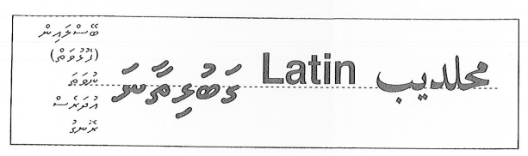
Thaana is written below the baseline while Arab and Latin above the baseline.

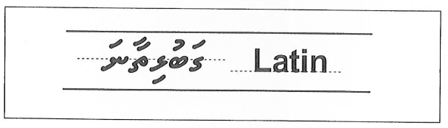
The introduction of Opentype with Windows 2000 it is possible to change the baseline within the same x height.

- Additional lines in Thaana diacritic and the space between two letters

The diacritic for different Thaana letters are positioned in various places for different letters. For example, the diacritic for ސ is written at right above the middle of the letter, but the diacritic for ހ is put level to the right side of the letter. In reality, the position of the diacritic is different for every letter in Thaana. This also depends on the type of diacritic to be used, while the position of the diacritic is different for various fonts and letters. So the position of the diacritic (in the object programming principle) must be determined in the font.
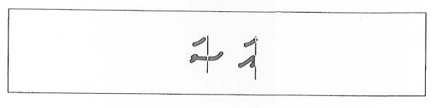
In Thaana “Fili” placement is vary to each “akuru”

Another point to be highlighted is that the space between two letters differs with relevance to the adjacent letter. For example, when writing ‘Naadu’ (ނާޑު) in Thaana, the base or bottom of ޑ touches ނ . To resolve this, the letter written first must be identified. However, the operating system does not have the capability to determine this because of the way letters are written in Windows. This problem occurs in Arabic and other languages as well. According to Microsoft, the introduction of open type A letters would be a solution for this.

- The order of Thaana letters

An official order of the letters used for writing Thaana, diacritic, the dotted letters for writing Arabic and English words in Thaana, has not been published. This causes obstructions in ordering the letters in computer and registering at the international administration for languages. Some people arrange the letters from the basic forms to the dotted forms and the diacritic at the end. However, this principle does not have a place for ޛ ޜ which are used when writing English words in Thaana.

My proposal for this is to place the basic 24 letters at first, then the letters for writing Arabic words, the letters for writing English words and the diacritic at last. The fonts I designed and launched in 1999 are compiled in this order. I believe that the time has come for an official order or arrangement for Thaana letters.

Several other issues, in addition to the aforementioned problems, are faced when writing Thaana in Windows. I will highlight on these issues during my speech as I do not wish to lengthen this paper.

4. Some ways to develop Thaana
The shapes of Thaana letters have seen many changes in the 400 years over which the letters were used for writing. The earliest Thaana writers cannot easily comprehend the Thaana we use nowadays. It is presumed that the shapes of Thaana letters will see more changes in the next 100 years. But unlike the earlier changes, bringing dignified and negotiated changes would make Thaana more popular and an empowerment for the development of the most scientific language in South Asia. If the Maldivians do not work to develop Thaana, no other persons would. It is important to give more attention towards Thaana as we begin a new millennium.
One of the biggest challenges to changing – reforming – Thaana will be that some people had established a close link to the language they are accustomed with. They will not be able to endure the idea of changing the letters. But we must realize that the letters will change, and the gradual change is brought about by humans. It is also important we acknowledge that the changes are brought for advancement. Those who propose changes must be aware that the changes would make writing and reading more convenient.
We need to focus on few points when bringing changes to the principles of writing Thaana:
- The change must allow a person who knows to read Thaana to easily learn and follow the modification
- The change must bring more conveniences in writing and reading Thaana
The changes proposed below are the opinions of one person. The purpose is to invite more people to think about these ideas. I do not believe that these changes are the best and the ideas presented by combined minds would be more rich and perfect compared to an idea presented by one mind. My first proposition is a change that can be brought to diacritic as these are signs that are frequently used when writing Thaana.
Modifications to writing diacritic
The modification to diacritic is mainly based on two things. Number one is to reduce the space used for positioning the diacritic in Thaana. The purpose of this is to find space to expand the letters. The second thing is to reduce the amount of time needed to write the diacritic. This will improve the speed of writing and in some instances, would be easier to read.
- Contract the Oabo fili (ޯ)

The Oabo fili was first used with an ‘ebe’fili (ެ) above the ‘obo’ fili (ޮ). The Oabo fili being used these days take up more space compared to other signs or diacritics used in Thaana. This means that the width between the two lines needs to be increased. As a result, few lines can be used for writing on a page and the letters have to be made very small if more lines are to be used on one page.

To contract the oabo fili, a modification can be bought by referring to the shapes of the other signs or diacritics. Most signs or diacritics are formed with a round shaped sign similar to an egg split into different parts.
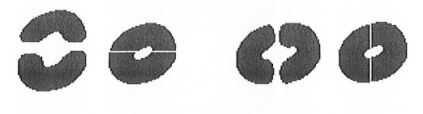
As mentioned earlier, splitting a ‘sukun’ (ް) to create an oabo fili would take up less space when writing. This is a solution to the cited issues. Some people may find the upper part of the sukun to be more pleasant. The two lines below are written using the proposed oabo fili.

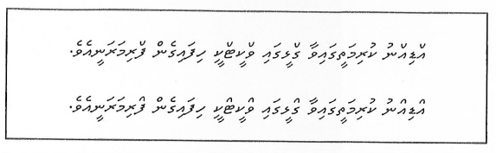
Very unpleasant, isn’t it? Some things become more striking when people become familiar with it. The ‘Vadaan kashi’ Thaana in illustration 5 contains this type of oabo fili.

- Modifications to the diacritic for lengthy sounds

Some diacritic used in Thaana to indicate lengthy sounds sometimes take up too much space that it has to be written on top of the adjacent diacritic. The most relevant example for this is the ooboo fili (ޫ), eybey fili (ޭ) and obo fili on top of the ހ. For example when ހޮހޮހޫހޫހޭހޭ are written together, it is difficult for the viewer and reader. It will be easier to read and write if the letters can be placed with its original space. In Thaana, lengthy diacritics are formed by doubling the short diacritics. How would it be to place a simple line next to the short diacritics to indicate the lengthy diacritics?
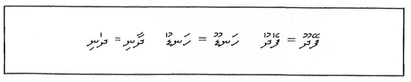

- Reduce space needed for ibi fili (ި)and eebee fili (ީ)

It has been earlier mentioned that the signs of Thaana can be enlarged by increasing the vertical space needed for writing Thaana. In this way, ibi fili and eebee fili are the only diacritics placed below the letter. But to place these diacritics, there must be space between all letters. As a result, more space is needed for writing and the letters become smaller. One solution for this is to place these two diacritics on top of the letter. This is a major change, so it may take a long time before the readers become familiar with it. The other option is to expand the x height of letters by bringing all the diacritics placing all the diacritics above the letter. But this means even more changes will be brought to the position of all diacritics.

If the ibi fili and eebee fili are to be placed above the letter, an extra sign will be needed as the readers need to differentiate them with aba fili (ަ) and aabaa fili (ާ). The next problem is related to that diacritic.

A moderate solution for the above mentioned explanation is to shorten the lower diacritics. When the diacritics are shortened, they become dots.
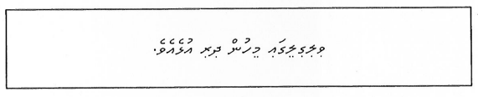

- Use diacritics instead of some sukun

According to table 2, އ sukun and ނ sukun are frequently used in Thaana. When these two sukun is at the middle of a word, the sukun can be used along with a sign on the previous letter. This is how ‘thashdheeh’ is used in Arabic language. Such diacritics are used in a similar way when writing Hindi language as well. This modification will speed up Thaana writing. That is because only one sign is needed in the place of two. The space needed for writing will decrease as a letter is not needed to be written. In my opinion, it will also be easier for reading.

Instead of using alif sukun as a sign, we will write a ‘saadhaa thashdeedh’ on the previous letter. ‘Saadhaa thashdheedh’ is in a lot more simpler shape compared to the thashdheedh used in Arabic. These thashdheedh’s are basically used as a dot on top of the diacritics. In this way, we will make a sign for ނ sukun as well. 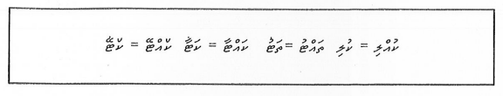

- Abolish aba fili

The most frequently used sign in Thaana is aba fili. This has been explained in table 1. While writing some languages, not having a diacritic on a letter means it has an aba fili. This principle is used in writing many languages in this region. If we adopt this principle and abolish the use of aba fili, Thaana writing will speed up. However, I do not support this change as it might affect the scientific principles of Thaana. But it is important to note that people in countries of this region do not face any difficulties in reading languages without an aba fili.
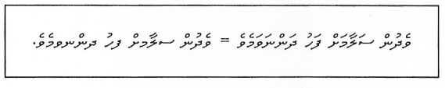
Changes to writing letters
The main change needed for letters is to make them more visible and simple. Such a change should be a convenience for reading and writing. In this regard, some changes can be brought to Thaana writing and letters.
- Shorten the ends of letters

Long ends are not needed to differentiate between specific letters. As mentioned in the page 7 of this paper, Bell believes that longer ends make it difficult to read. So when longer ends are used, except in cases where it is mandatory to differentiate between letters, reading becomes difficult and more space is needed for writing. Shortening the ends of letters is not a real change, but going back to the initial form of Thaana. The font used for writing this paper is of letters with short ends, but is it any more difficult to be read compared to other papers?

- Straighten the letters

It has been noticed that the human eye finds it easier to look at parallel lines instead of vertical lines. An earlier section of this paper had discussed on that point. I have never seen an official language other than Thaana where frequent vertical lines are used in writing. It might be a positive sign for Thaana to have some parallel lines. Including more parallel lines in Thaana would especially make it easier when computers are used for reading and writing.

At the time of preliminary use, such parallel lines might not be pleasant for readers and writers, but in time it will become more popular. The vertical or slanted letters being used now can be used along with the letters with parallel lines. This is how it is in all languages.

- Broaden the shapes

Letters are differentiated by its shapes. So broadening the shapes of letters which are difficult to recognize would make it easier to read Thaana. For example ‘ށ and ނ have slight differences. This difference can be broadened by two ways. One way is to increase the height of the short upper angle in the middle on ނ. The second way is to deepen the space between the two angles in ނ. These two ways are already being used by writers. Broadening the shapes of all such letters would make it easier to read. Consider the differences in the two words presented below.
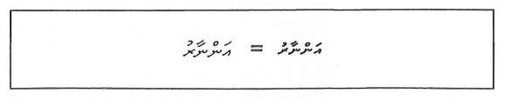

- Make ޗ simpler

ޗ is the only letter where a long end extends upwards. Other letters similar to ޗ have a different shape. In my opinion, it is important to design a new shape for ޗ . One of the designs that can be adopted is presented below.
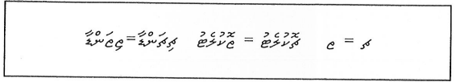

- Simplify some more letters

Some letters in Thaana can be changed to distinguish between different letters and to create more visibility and increase the speed of writing. In this regard, ބ, ފ, ދ, ތ and ޑ are letters that can be simplified. One way to simplify ބ is shown in illustration three by leaving the front curve open. ފ can be changed by adopting the earliest form of the letter (illustration 3). ދ and ޑ can be simplified by not using the first curve. ތ can be written in a shape similar to ވ.
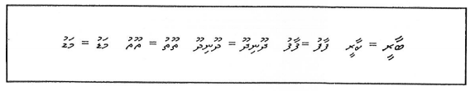
ސ is very different to other letters. One reason is its length, which causes difficulties in using diacritics and takes up more space when writing. The second reason is its flatness, the relatively low x height for ސ. This causes ސ to have an odd look when placed with other letters. The ސ has some similarities to the ސ letter in Urdu and Persian. This paper has earlier highlighted that Abdul Azeez Yoosuf had looked into ways in which ސ can be modified.

5- Internet and Thaana web pages
Internet has gained momentum in information technology. The internet usage in Maldives is increasing day by day. The internet will become an important resource for writers to gather information and publish their works. In this part of the paper, I will present a short introduction of the internet and the use of Thaana in web pages.
Internet is a network of computers. In my opinion, the word was formed from inter-network. In Maldives, inter-school is used to refer to activities between schools. In this way, inter-network refers to activities between computer networks. So internet means the system that connects several inter-networks. When all networks are connected, a large single platform or network is established. This platform is called the internet. In other words, internet is a network of networks.
An established principle is needed to connect many networks. This is because the networks of the internet are based in different cities and islands. For this reason, computers use an established protocol for communication. Internet was founded and expanded in 1973 when the protocol for communication between computers was recognized.
Most people believe that the internet was founded in 1968 when the US Defence Ministry launched the ARPANET for scientific research into computer networks. The ARPANET was connected between four popular universities in 1969. In 1973, this network crossed the Atlantic Ocean and was connected with Europe. This was the year in which the computer protocols were established. In addition to the protocol, there were two other reasons for the fast expansion of the internet. First thing was that the internet was not controlled by any central authority. The second thing is that there were many routes by which messages can be sent from one computer to another. As a result, messages can be disseminated even if one network is damaged, that is by choosing another route other than the one which faced the problems.
In the 1980s, the internet was mainly used for sending electronic letters (email), sending files from one location to another and establishing a platform for discussion between like-minded people by sending messages. Additionally, various media platforms were also using the internet.
Over the past ten years, the internet has widely expanded. That happened in 1991 when the main European center for research (CERN) found a way to connect the information in the internet. This was called the World Wide Web, in short web. The web shows information on the computer screens as pages. Web pages can contain writings, color illustrations, audio and video. Related or relevant pages can also be immediately accessed through the web. The user does not require knowing the location from which the information is provided. The pages containing text, audio, video and related content in the form of links is called hypertext pages. If one computer contains such a page, that computer is referred to as a website. The front page of a website is called the home page.
The programs used for viewing web pages are called browsers. The first browser ever used was the Mossaic. It was founded in 1993. With the introduction of this browser, internet usage increased by 300,000 percent. The most popular browsers now are Internet Explorer and Netscape.
The most frequent activity in the internet now is sending messages or emails to one another. The second most frequent activity is viewing webpages. As a result, webpages are the most important element of the internet. According to statistics, about 8 million websites were registered in the internet by 1999. The Maldives was registered for internet usage in 1996.
Reasons why the internet is important for writers
Information technology is bringing major changes to the world. Information technology, especially the internet, is very important for writers, mainly because of the below mentioned reasons.
- Internet can protect massive information and the location to store this information is not relevant.
- Information in the internet is easily accessible at almost no cost and can be disseminated without much effort
- Information can be gained at any time, in any form, at the will of the user
- Information can be gathered and provided with rich content such as audio and video compared to information provided on paper
- Internet can be used as a platform to advertise published works, to sell these items and to transfer it to the readers
In addition to the above mentioned reasons, internet is important for writers to find out opinions, share messages and have discussion platforms. Its importance to writers will grow as the internet grows. For this reason, Maldivian writers need to become more familiar with the internet.
Designing Thaana webpages
When webpages were designed, the designers did not see that the languages other than those used in Europe might be needed for the web. Over the past five years, with the rising importance of countries speaking other languages, webpages in these languages are gradually emerging. However, there are still no arrangements in which browsers can be automatically viewed in the language it was designed. It is predicted that Windows 2000 to be out in February 2000 would have the feature to design webpages in any language. The principles to be used for this have now been included in the Html 4.0.
*(See Illustration) When this change is brought, the webpage can be read in any browser. A webpage may include many languages. The reader will not have to do anything else to access that page. But this change might also bring some challenges. It increases the time needed for downloading a photo from the web. This means an extra burden on internet users as it will make costs higher. When writings are included as pictures, the size of the letters cannot be maximized or minimized, based on the screen resolution. Designing webpages in this format takes up more time as well.
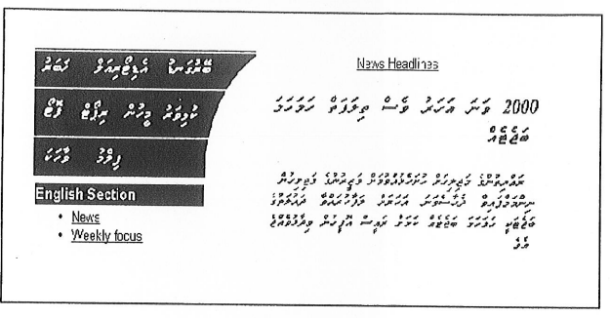
A thaana webpage. All thaana is a bitmap image.

In contrast to this format, highlighting Thaana webpages with a tag or sign and instructing the browser to use a specific font would be more effective. This is how Arabic webpages are also designed. The webpages can be viewed in any country- anywhere. However, computers that do not have Thaana/Arabic font cannot read the letters. Font is not sent along with the webpage. It is because fonts are designed from companies, and it is illegal to sell or provide the fonts in the black market.
A new technology was formed in 1999 to resolve this issue. The new technology is called font embedding which means to strictly embed or store an element inside another tool. When the font is embedded on the webpage, users cannot use that font for their own purposes. It can only be used to view the accessed webpage. This was an end to the complaints from companies designing fonts. Two different principles are used by two companies to embed fonts in webpages. One principle is called TrueDoc and the other is called Embedded Open Type. Maldivian writers design webpages using these two technologies.
Making Thaana more web friendly for the benefit of writers
In the coming days, the development of Maldivians depend on how much Thaana is used by writers. Most articles even now are being written using computers. Web might become a resource where books from Maldivian writers are stored and shared. For this reason, articles by writers need to be available in the internet in the form of webpages. It is also important that writers use web to collect information.
I believe that this can be done when those promoting Dhivehi language adopt more modern facilities. One thing that can be done is launching a website on Thaana and Dhivehi language. The Dhivehi dictionary can be made available for users on the website along with documents about Maldivian literature. In other website about language, plans on how language related classes can be conducted, short reviews on newly published books and information on bookshops are included. Such a website can also include fonts and software needed to use Thaana on the web.
As information technology is expected to play an important role in developing and using Dhivehi language and Thaana, it is imperative that we think about these things, make plans and implement early measures. Development of the writers- development of Dhivehi Language is dependent on what is done in this line. Let’s put an extra effort to develop Thaana with the beginning of the new millennium. Let’s give the opportunity for Thaana to become more familiar with information technology.

